A modal transfer enhanced deep learning for structural dynamic response with sparse spatial data
In this document, we present a structural response reconstruction model for sparse spatial measurement conditions: a Modal Transfer Enhanced Deep Learning (MT-DL) approach. The fundamental principle of this method is as follows:
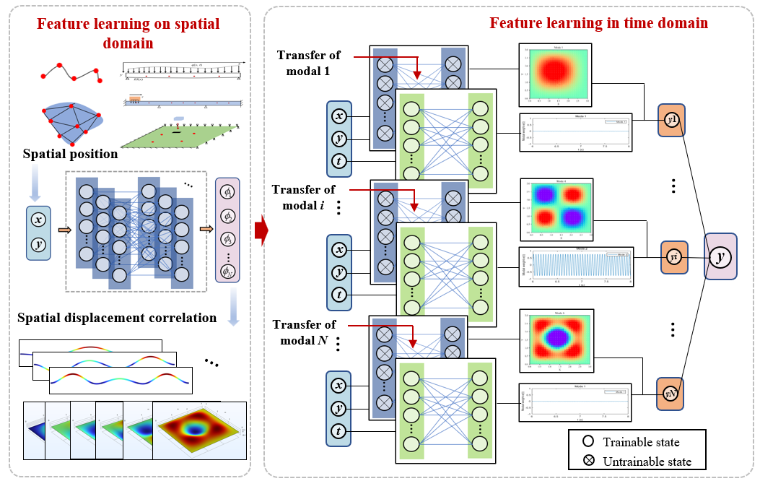
Fig. 1 Schematic diagram of MT-DL model.
In structural dynamics, the natural frequencies and associated mode shapes of a continuum or discretized system constitute its intrinsic vibration characteristics. Under arbitrary external excitation, the time-domain response may be rigorously expanded as a superposition of modal contributions. Specifically, for a two-dimensional elastic domain, the displacement field admits the representation:
(1)
Where denotes the i-th eigenmode (mode shape), and is the corresponding modal coordinate. The mode shape encapsulates the spatial deformation pattern, i.e., the relative displacements across all discrete nodes (e.g., beam, plate, or spring elements) under the i-th vibratory state.
Motivated by the foregoing, a modal-transfer enhanced deep learning (MT-DL) framework is proposed, which combines the neighborhood-aggregation mechanism with classical modal analysis to enable reconstruction and prediction of full-field structural responses (see Fig. 1). The proposed MT-DL model comprises two principal subnetworks:
- Mode-Shape Network
The primary objective of is to learn the mapping
(2)
Wherein the input spatial coordinates are mapped to mode-shape amplitudes. Implementation may employ fully connected feedforward networks (FCNNs) or graph convolutional networks (GCNs). Upon convergence, yields node-wise modal embeddings, which define a spatial adjacency (or correlation) function and are thereafter frozen to serve as a fixed physical prior.
- Time-Evolution Network
The network models the temporal evolution of the displacement field by consuming, at each time step, the prior state w(t−Δt), and the pretrained modal embedding . Architectures such as FCNNs, recurrent neural networks (RNNs), long short-term memory networks (LSTMs), or GCNs may be employed.
The training procedure proceeds in two stages:
- Stage I: Spatial Correlation Learning.
The mode-shape network is trained against high-fidelity modal data (obtained via numerical eigenanalysis or experimental modal testing) to minimize.
(3)
Upon attainment of a prescribed accuracy, the parameters of are rendered immutable.
- Stage II: Temporal Dynamics Learning.
Embedding the frozen within , the composite model predicts:
(4)
The loss function is defined as:
(5)
Notably, only sparse spatial labels are required to supervise , thereby markedly reducing data acquisition demands.
The framework offers several key advantages: physics-informed interpretability is ensured by embedding modal information consistent with established vibration theory; data efficiency is achieved as only sparse measurements are needed for full-field reconstruction; enhanced generalization arises from a frozen mode-shape backbone that remains robust against variations in loading or slight changes in structural parameters; and broad applicability is demonstrated—not only on canonical beam and plate geometries but also in its ready extension to the flexible riser for real-time health monitoring and prognostics.

In the code repository, we provide four sets of files:
- Section 3: Includes the implementation of the DL, GCN, and MT-DL models, along with modal and vibration data of a variable-stiffness beam.
- Section 4.1: Simulation of continuous beams under moving load.
- Section 4.2: A plate with complex boundary conditions subjected to impact loading.
- Section 4.3: Vortex-induced vibration of a flexible riser.

Author's Email: 2111378@tongji.edu.cn

